Project 2: Date System Call

CIS 450 Operating Systems

By Marco Seman

Due: Tuesday, February 12, 2019

In the user.h file, we added the new function, int date(struct rtcdate*), noticed that the parameter is a struct with a pointer, because ….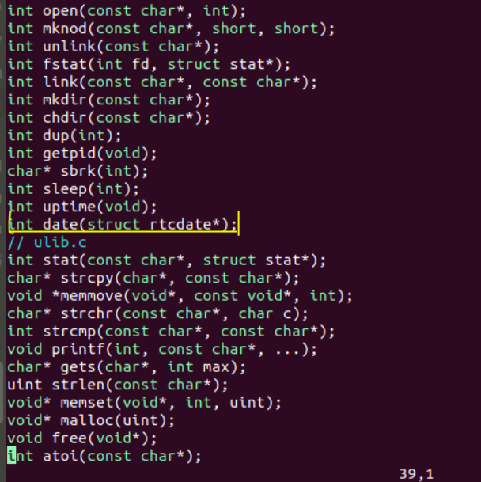

In the usys.S file, we added the SYSCALL(date) function

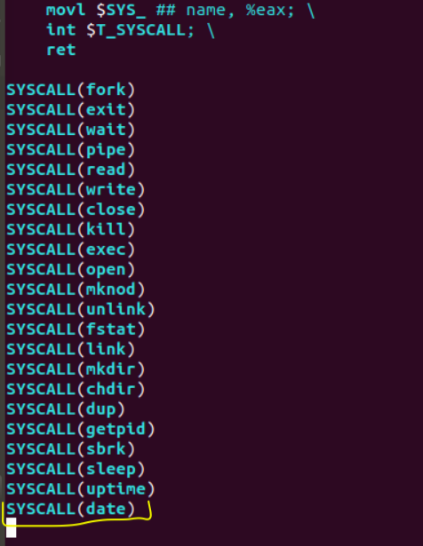

In the syscall.c file, we added two function, the extern int sys_dat(void);

and the [SYS_date] sys_date

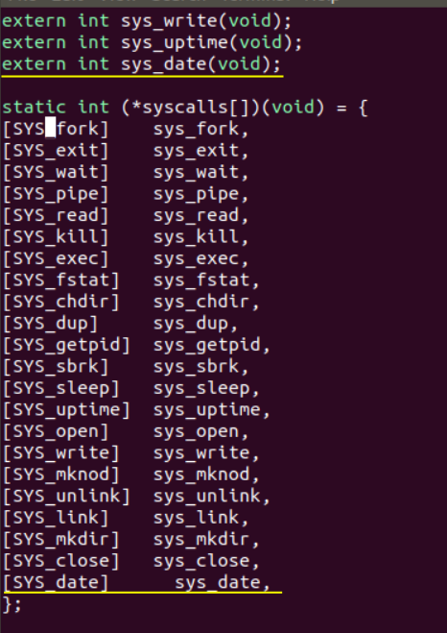

In the syscall.h file, we add the new system call and the number of the system call

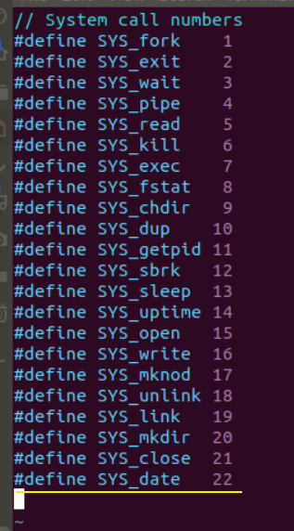

In the sysproc.c file, we implement the main date system call function

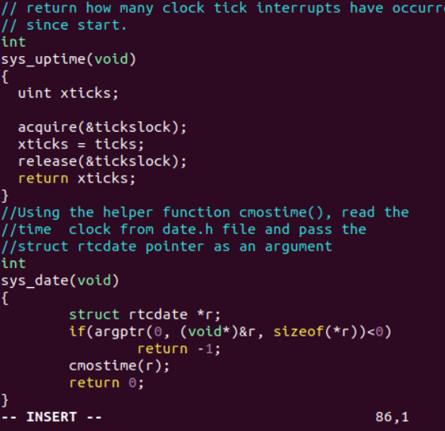

Screenshot of date:

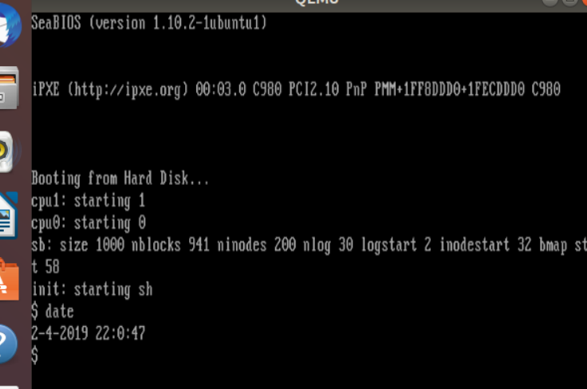

What we learned:

For our second project, we learned how to add a new system call to xv6. In the xv6 folder, we created a program that would obtain our machine’s current UTC time and return it to the user’s terminal. We learned that in order to implement a date system call program, we must also make modifications to other files that use such information such as: user.h, usys.S, syscall.c, syscall.h, sysproc.c.

The user.h file is used to define the functions that can be called through the shell and in there we called the file date and created a pointer to the rtcdate variable. usys.S is used to define the connection call of the user to the system function call and from there we created a system call for date. Syscall.h is used to define the position of the system call vector that connects our implementation, so in there we defined the system call for date. Syscall.c is the function that connects the kernel and shell and uses the position of the system call used in system.h. Sysproc.c is where we add the real implementation, we created the function that contains a struct with a pointer, using that pointer, we read the real time clock located at the rtcdate variable, if the time and size is less than 0, return -1, else the system will pass the pointer as an argument to the helper function cmostime() and to retrieve the real time clock.

In the end, when we ran the date.c file, which calls our system calls, the size of the address space of the program, and the UTC time and date of our machine.